**CADENAS Extends Relationship with PTC® and Delivers One of the World’s Largest Online Catalog of PTC® Creo® CAD Models**

**AUGSBURG, GERMANY June 18,** **2013 - CADENAS GmbH today announced the launch of the new PARTcommunity for PTC®, offering one of the world’s largest online catalog of CAD models in native formats of PTC Creo® design software. The community portal gives mechanical design engineers instant access to configure and download millions of certified native 3D CAD models from over 400 industrial supplier catalogs, at no cost to the engineer.**

**View the portal:** [**http://ptc.partcommunity.com**](http://ptc.partcommunity.com)

**“The launch of PARTcommunity for PTC marks another giant stride in providing PTC Creo customers with the best tools and resources to help make their jobs easier,” said Brian Thompson, VP Product Management, PTC. “CADENAS helps us deliver the exceptional value our customers have come to expect.”**

**Engineers can search supplier catalogs for the exact component part they need, configure product options, see an interactive 3D preview and then download the model for insertion into their PTC Creo environment.**

**“These capabilities save engineers a significant amount of time and cut down on design cycles,” said Walter Leder, VP of CADENAS. “It’s all about the total customer experience. That’s a philosophy we share with PTC and we look forward to continuing to work with the PTC team to provide the best solutions to engineers everywhere.”**

**In addition to the online engineering portal, CADENAS will also be working closely with PTC to deliver additional complementary solutions.**

You can download the text on: [www.cadenas.de/press/press-releases](http://www.cadenas.de/press/press-releases)

Press Photo

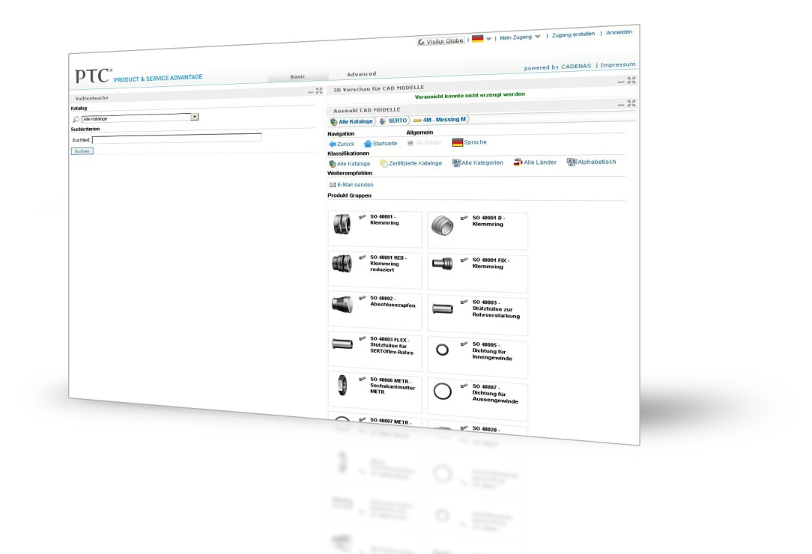

**Caption: The community portal gives mechanical design engineers instant access to configure and download millions of certified native 3D CAD models from over 400 industrial supplier catalogs, at no cost to the engineer.**

**You can download the photo** [here](http://www.cadenas.de/presse/reader/items/cadenas-baut-die-zusammenarbeit-mit-ptc-aus-und-liefert-einen-der-weltweit-groessten-online-kataloge-fuer-ptc-creo-cad-modelle-9?file=tl_files/cadenas/images/news/ptc_portal_final.jpg)**.**

About CADENAS GmbH

CADENAS is a leading software developer in the areas of Strategic Parts Management and parts reduction (PARTsolutions), as well as Electronic Product Catalogs (eCATALOGsolutions). With its customized software solutions, the company acts as a link between the component manufacturers with their products and the purchasers.

With its 300 employees at 14 international subsidiaries, the name CADENAS (Hispanic: process chains) has been standing for success, creativity, support and process optimization since 1992.

In its role as initiator and mastermind, CADENAS has already established many innovations and trends.

**PARTsolutions Innovations:**

* Topology search for CAD components
* Geometric Similarity Search of CAD components   
  runs automatically in the background
* Search for CAD parts by sketching

For further information about our newest innovations and the company, please visit our website at: [www.cadenas.de/en](http://www.cadenas.de/en).

PTC and Creo are trademarks or registered trademarks of PTC Inc. or its subsidiaries in the United States and other countries.